ACTS of the Apostle News
Acts of the Apostle Assembly 2411
Fourth Degree Knights of Columbus

SK Tom Curtin, Editor. tomcurtin@gmail.com
June 2023

Contents
Faithful Navigator……………………………………………………………………………
Captain’s Log…………………………………………………………………………………
Admiral’s Overview……………………………………………………………………………
Pilot’s Memo……………………………………………………………………………........
Friar’s Blessing………………………………………………………………………………
Purser’s Account…………………...………………………………………………………….
Comptroller’s Ledger…………………………………………………………...……………
Scribe Notes..................................................................................................................
Sentinel Sightings...........................................................................................................
Trustee Talks..................................................................................................................
Color Corps Commands..................................................................................................

Assembly Officers

Officer | Name | E-Mail | Phone
Faithful Navigator | Rupert Harmon | rupertsellshomes@aol.com | 703-969-1488
Faithful Friar | Fr.Robert Wagner | frwagner@st-andrew-clifton.org | 703-817-1770
Captain | Tony Paulson | anthonyepaulson@gmail.com | 703-231-4800
Pilot | JD Caraway | carawayjd@gmail.com | 571-882-0726
Admiral | Al Grimmig | algrimmig@gmail.com | 571-426-0401
Purser | Art Luna | ajlman@aol.com | 571-261-9823
Comptroller | Daniel Vigil | Dbv71@yahoo.com | 703-444-7931
Scribe | Anthony Estrada | a.estrada2411@outlook.com | 703-964-7530
Inner Sentinel | Mike Paulucci | michael.paulucci.kofc@gmail.com | 571-606-7648
Outer Sentinel | Eric Latcheran | Zydecolady1@gmail.com | 571-225-3883
1 Year Trustee | Paul Hannan | pthannan@gmail.com | 571-276-3927
2 Year Trustee | Bill Cormier | cormierw@hotmail.com | 303-717-4830
3 Year Trustee | John Titus | Titus9265@hotmail.com | 703-586-5766
Commander | Paul Hannon | pthannan@gmail.com | 571-276-3927
Editor | Tom Curtin | tomcurtin@gmail.com | 703-338-4804

Charter ceremony for St. Jude Council on May 20th, 2023. State Deputy Pat Rowland, District 19 Deputy John Masarick and Pastor Fr. Nicholas were present for the event.

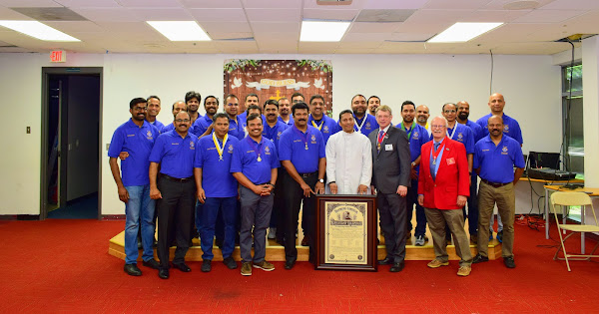

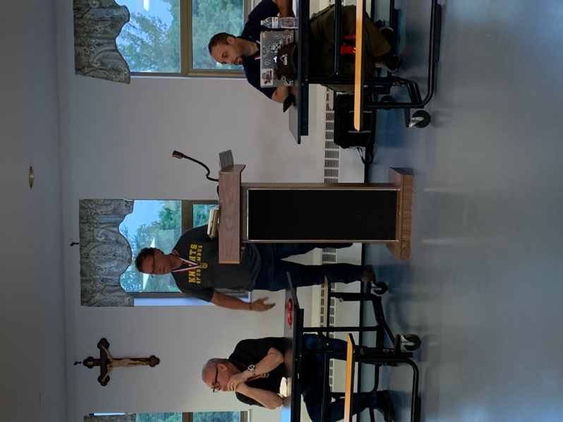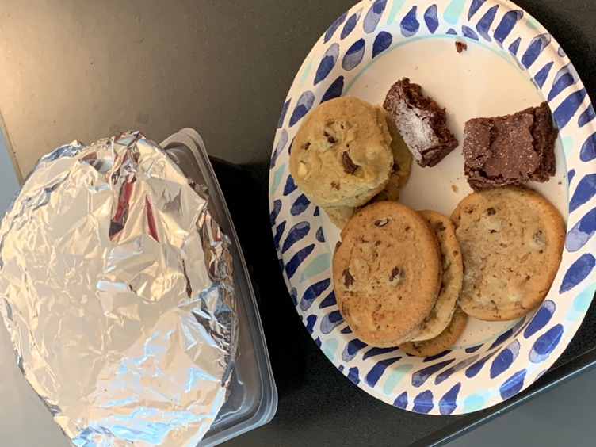
Master Chef Rob Morson prepared BBQ Ribs and assorted deserts. This is a portion of leftovers.
Faithful Navigator Rupert Harmon conducting the May meeting,
accompanied by
Comptroller Daniel Vigil (L) and
Scribe Anthony Estrada.

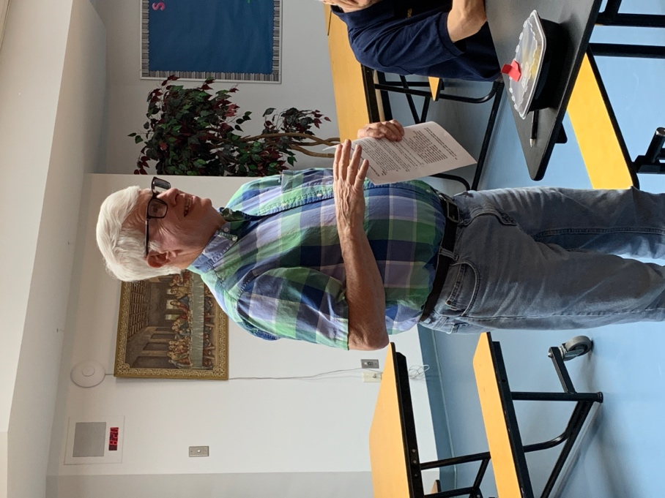
Color Corps Commander and Trustee reported that the St. Veronica Council has won the State Award for Family Activity.

Faithful Navigator
Worthy Sir Knights
The fraternal year that is coming to a close has been good- no great. We finally began meeting as we would normally without fear or favor. The assembly and its awesome Christian soldiers overcame the challenges of the recent years. I have truly enjoyed my time as navigator and especially the latitude of topics that often came up in my report to the assembly.
Since the main precept for the 4th degree is Patriotism, it is not always easy in this day and age to define it. Sometimes our system of government leaves us questioning the patriotism we all may feel but not all agree with. Our country is going through growing pains some might say. It's dicult at times to believe that everyone in our government has our countries best interests at heart.
I was very happy to have added St. Jude council to our assembly. They are a great addition and look forward to having some of the Sir Knight's from their council added to the our ranks. I also will be seeing them in my district 17 as they were added by our state deputy. If you weren't aware I am the new District Deputy of 17 and look forward to seeing them at their meetings soon.
The Christmas party this year was well attended, and everyone seemed to have enjoyed themselves. I had hoped to have another party, but time ran out unfortunately. I think one thing I've thought about the 4th degree that members would enjoy is more social events that would include our wives. Maybe that's something for next year.
Attendance this year was pretty good as well. I think we averaged around 25. As in most things KOC our councils and assemblies thrive when we have participation by a large number of brothers. We must keep trying to recruit at the councils, so we continue to grow.
Our Faithful Navigator elect SK Tony Paulson will be an awesome leader and I look forward to supporting him in any way possible. I won't be too far however, I'll be moving into the Admiral position and have mighty big shoes to fill after SK Al Grimmig becomes a Trustee.
As always, I am around if a brother needs help and or has a question or two. I look forward to the next meeting on June 26th for my last meeting as Faithful Navigator and I'll be passing the gavel to brother Tony!
Rupert Harmon

Captain’s Log
Brothers,
Let me start by saying how honored I am to be chosen as your new Faithful Navigator. Although due to my past work schedule and taking some classes, I was not active in the assembly for a while, I think I’ve made up for it during the past two years. I’ve even gotten the new uniform and just today (June 8th) picked it up from being altered and I plan on wearing it this Sunday for the Corpus Christi processional—air quality permitting.
I’m still feeling my way through some of the activities of the 4th degree, and I will be leaning on our PFN’s for guidance.

Some news first, then a discussion about next year. Father Wagner, has tendered his resignation as our Faithful Friar. He was trying to fulfill his duties on his one day off a week and, as he put it, it wasn’t working out for either him or the Assembly. He did propose our incoming Parochial Vicar, Father Charles Wilton, as our next Faithful Friar. Father Wilton spent 14 years as a Navy corpsman reaching the rank of Chief Petty Officer. His service included deployments to Afghanistan and Iraq. He is currently in the Navy’s Chaplain Candidate Program. While he is currently not a 4th degree, that is not a requirement to be Faithful Friar. We’ll work on that as soon as he arrives in the parish. After consulting with the trustees, I will be asking Bishop Burbidge to appoint him as our Faithful Friar.
As the new fraternal year begins, we must pass a new budget, and I hope by the time this newsletter is published, you will have seen my proposed budget. One of the realities we face is we haven’t had any fundraisers, notably the car raffle, in the past few years. I’ve zeroed out fundraisers in this year’s budget, but we’ll form a committee to explore and propose new fundraising activities. As a result, the proposed budget is NOT A BALANCED BUDGET. Fortunately, we have what I consider a healthy bank balance. So, while we’ll be spending more than we take in, at least we’re avoiding deficit spending, unlike the government.
What that also means, is we’ll focus our spending on those things that revolve around the principle of the 4th degree—Patriotism and long-standing assembly practices. I will be reluctant to support spending that does not fit into those categories. I want to avoid what we call in the military, “mission creep”.

Onto what I want to work on this year: growing the Color Corps, more patriotic activities, and communication. In the District organizational meeting this past Saturday, it was repeatedly emphasized that the 4th degree is the visible arm of the Knights of Columbus. And the Color Corps, through its appearance at funerals, parades, and public ceremonies is the embodiment of that visibility. The more people that participate, the less demand on the individuals that participate. Some of the Color Corps activities are scheduled well in advance, and we’ll make those events known. Funerals of brother Knights, and their family members, are obviously not scheduled in advance, but we should have at least several days’ notice. And to help defray the cost of the uniform, we are subsidizing the full cost of the uniform for those Sir Knights who purchase the uniform and participate in Color Corps events. Based on a cost of $450, $225 is reimbursed when the uniform is purchased and $225 is reimbursed after the Sir Knight participates in four Color Corps events. I believe we still have sufficient funds to subsidize at least two more Sir Knights purchasing the new uniform. And while I just purchased a uniform, I’m going to delay requesting reimbursement for at least six months, to allow more Sir Knights to have the cost of their uniforms subsidized.

In the area of patriotic activities, during last Saturday’s organizational meeting, it was mentioned that only 3 of Virginia’s 38 assemblies submitted the forms to be a Star Assembly. While I’m not usually big on awards, if it’s a matter of documenting things we already do, I believe submitting the documents is the least we can do. One of the prerequisites for the Star Assembly Award is the Civic Award, which requires supporting/participating in four patriotic activities. We already have money in the budget to support Wreaths Across America and Ride 2 Recovery, which I presume would count. I believe having a presence at the Father Capodanno Mass and the Columbus Day ceremony downtown would also count. I’m going to consult with the District leaders and review other newsletters posted on the State website to see what we can do.

Thirdly, I’m going to work on improving communication within the assembly. Over the years, both in my council and in the assembly, I’ve heard questions about what’s in the bylaws, just what was passed when, etc. To that end, I’m going to take steps to re-activate our website on UKnight (https://uknight.org/Assembly.asp?A=2411). As best I can tell, the site was last updated in 2019. I’m really looking for a place to keep a copy of the bylaws, past meeting minutes, financial reports, etc, as well as providing a way for more people, like the Color Corps Commander, to email the Sir Knights. The Faithful Navigator can send an email to the assembly through Officers Online, but that makes me a single point of failure, which I want to avoid. All those things are possible for councils on the UKnight site, and as I'm writing this, I’m exchanging emails with the UKnight help desk to see if it can be done for the assemblies. For emails, whether they come through the Supreme website or through UKnight, I will try to remember to have the subject line start with “Acts #2411” to make it easy to spot emails coming from the assembly. Whether that means you pay particular attention to those emails, or ignore them, I leave it to you.

A couple “housekeeping” comments. Two of the limitations we have using Monsignor Hannan Hall revolve around timing. First, during the school year, the school’s aftercare program may be using the hall until 6 PM. That may limit how early we can get into the hall to setup. Secondly, we are supposed to have the hall vacated by 9 PM. Part of the reason to be out of the hall by 9 is so the cleaning crew can get in there, clean, and get done at a reasonable hour. What are the practical implications of that? First, while the Faithful Pilot is primarily responsible for setting up the room, everyone should be helping to get the room ready. And everyone should assist in returning the room to close to the original configuration. That includes wiping down tables and sweeping/mopping the worst of the food debris off the floor. As they say, “Many hands make light work”. Join me in keeping the work light. Bottom line—we’ll try a few new things in keeping with our patriotic mission and continue our 4th degree traditions, including our great dinners before our meetings!
Fraternally,
SK Tony Paulson, PGK
Faithful Captain, Incoming Faithful Navigator

PS. A few of you know I spent over 20 years in the Air Force. During that time, I was taught that Air Force communications should be concise and succinct. I will try to keep future columns more succinct.
Editor’s Corner

The Faithful Navigator and the Faithful Captain have submitted articles for this issue. Our humorous Faithful Scribe submitted a mysterious one-liner.

I felt a need to address some issues that affect our Catholic faith and have included articles regarding capital sins, justice, and guns. They were written by a journalist, an Archbishop, and about a Cardinal by another journalist.

I would love to hear from our membership more often. I have asked for short bios, since these are subjects that you know well, yourselves. It would be nice to let your fellow Knights know about you.

SK Tom Curtin
Editor

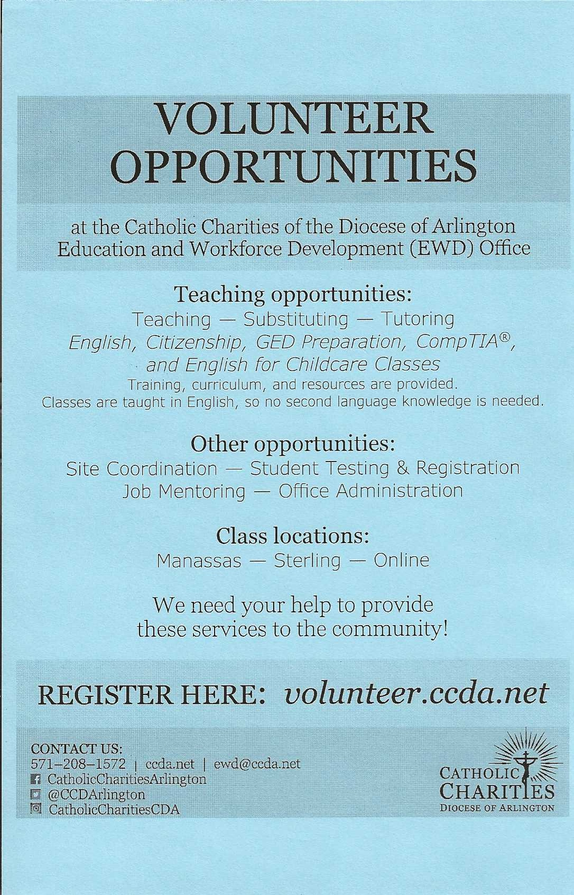

LGBTQ’s false religion paints in rainbow colors of sexual anarchy and criminalization of dissent
By Robert Knight
OPINION:
If nothing else comes of the Los Angeles Dodgers’ bizarre embrace of the Sisters of Perpetual Indulgence, it is striking evidence that a false religion is out of control.
Virtually all major league sports teams and dozens of minor league teams have caved to the LGBTQ religionists. “Pride” events dominate June, formerly known for weddings and Father’s Day. Talk about cultural appropriation.
The Washington Post recently devoted an entire Religion page to two articles bashing “Christian nationalism.” Both were sourced from an atheist organization.
Signs of a new Dark Age are everywhere. When you see a rainbow flag draped over a cross in front of a “woke” Methodist church, it’s the equivalent of the Muslim practice of erecting mosques on the ruins of churches. The message is clear: This is captured ground.
Created in 1978 by artist and drag queen Gilbert Baker, the rainbow flag is billed as a harmless symbol of love, tolerance and diversity. It is not. It heralds the rise of atheistic paganism in which adherents reject God and make up reality to satiate their desires. At its most extreme, it leads to persecution of noncelebrants.
Americans are a tolerant people. But we should realize by now that sexual deviance has become a club with which to clobber Christians and Jews and destroy First Amendment freedoms. The rainbow flag’s religion has two main goals: sexual anarchy and criminalization of dissent.
Target has introduced women’s swimsuits with a pouch built into the crotch. It is marketing pride T-shirts designed by an avowed satanist whose website has featured a “homophobe headrest” with a picture of a guillotine.
This past week, the Dodgers disinvited the Sisters of Perpetual Indulgence after Catholic groups expressed outrage. The drag queens in nun outfits have obscene names, peddle hatred and revel in blasphemy. They even sexualize Jesus and Mary. They have no business being honored in a supposedly family-friendly major league baseball stadium.
After the LGBTQ lobby waved its pinkie finger, however, the Dodgers quickly folded and issued a craven apology and reinvitation. Score: LGBTQ activists 666, 4 million LA-area Catholics 0.
The Babylon Bee satirized the cave-in: “Dodgers Summon Satan to Throw Out First Pitch at Pride Night.”
The Bible teaches that everyone is a sinner — no exceptions — and that salvation comes through conviction of sin, then repentance and forgiveness. The most common symbol of Christianity is the cross. It’s a reminder of the greatest act of selfless love in history.
The rainbow flag, by contrast, signifies a false, self-focused faith. This religion repudiates the need for repentance and redemption. It holds that God does not exist or is indifferent to sin. A corollary is an idea that perhaps sin exists but that all sexual sin is somehow exempt and even laudatory.
Either way, this is not love. It’s unkind, not liberating, to suppress the truth about earthly and eternal consequences of unrepented sin and to deny hope for change.
This is why same-sex marriage is the opposite of the real thing. Created by God, marriage unites a man and a woman who vow to love and honor each other.
A same-sex ceremony borrows the trappings of marriage. And though the partners’ love may well be real, the unspoken vow is this: “I will never repent of my sinful behavior. And I will do everything in my power to keep you from repenting.”
This is why many Bible-believing Christians opt out of an LGBTQ wedding while continuing to love and pray for their friends and relatives. Wedding attendees are not merely witnesses; they are part of the ceremony, lending their spiritual assent to the union.
Just as Christians build churches and cathedrals, the LGBTQ religion has its own versions. Their “churches” once consisted mostly of bars and bathhouses. They now include campuses, baseball stadiums, U.S. embassies, public schools and “woke” churches that sport the rainbow flag.
Perhaps the most important LGBTQ cathedral is the Kinsey Institute at Indiana University. A predatory sex addict, Alfred Kinsey was a high priest of the LGBTQ religion. His voluminous “studies” on male and female sexuality, compiled with fake research to suit his desired outcomes, are bibles of false faith.
Some good news is that Indiana lawmakers finally have defunded the Institute. The late Judith Reisman, who co-wrote “Kinsey, Sex and Fraud,” published in 1990, would be elated.
The more encouraging news is that Americans are letting corporations know they’re sick of “wokeness.” Bud Light’s parent company has lost $18.8 billion in market value, and sales of Bud Light are down by more than 23%, according to Fox News. Target’s market value has plunged by $9 billion so far.
Pushback is overdue and welcome, but something bigger is needed to save America.
Many find inspiration in God’s promise from 2 Chronicles 7:14, which says that if “My people” will “turn from their wicked ways, then I will hear from heaven, and will forgive their sin and heal their land.”
A lesser-known verse is this, Jeremiah 18:8: “If that nation against whom I have spoken turns from its evil, I will relent of the disaster that I thought to bring upon it.”
May it be so.
• Robert Knight is a columnist for The Washington Times. His website is roberthknight.com
Reprinted from the Washington Times, May 29, 2023

Wall Street Journal

California Catholics Under Attack

Vandals get off with a misdemeanor charge for defacing a statue as police looked on.
By Salvatore J. Cordileone
“History never repeats itself,” Mark Twain is supposed to have said. “But it rhymes.” Consider the American Catholic Church over the past two centuries.
In 1834, a frenzied mob attacked and burned to the ground a convent of Ursuline nuns outside Boston. The act was the culmination of years of anti-Catholic preaching and aggression toward the church’s property. None of the firemen present intervened, and some reportedly joined the riot. Later that century, the Know Nothing Party emerged to suppress the rights of German and Irish Catholic immigrants, fearful of a Catholic conspiracy to take over the country.
Not long after that, the Ku Klux Klan began to terrorize black Americans, Catholics and Jews. In 1921 an enraged Klansman fatally shot Father James Coyle after the priest celebrated the wedding of the gunman’s Catholic-convert daughter to a Puerto Rican man. The killer was acquitted at trial by a Klansman judge and Klan-filled jury.
Our nation is now struggling to come to terms with its history of racism. Yet universally ignored is its long, deep and sordid history of anti-Catholicism. The U.S. Conference of Catholic Bishops reports that “at least 260 incidents”—attacks on church property—“have occurred across 43 states and the District of Columbia since May 2020.” The behavior runs the gamut, from arson to spray-painting, beheading and toppling statues, to defacing gravestones with swastikas and anti-Catholic messages. Arrests in these cases, and especially prosecutions, have been extremely rare.
One who was arrested is John David Corey, who in July 2020 set a devastating fire at Mission San Gabriel Arcángel, the historic Los Angeles-area church founded by St. Junípero Serra in 1771. Law enforcement told local news at the time that Mr. Corey had a history of conflict with the Catholic Church. In December 2022 he was ordered to stand trial on several counts of arson and burglary, to which he has pleaded not guilty.
Our brothers and sisters in Los Angeles aren’t alone. Catholics in the San Francisco area have weathered our share of attacks too. In October 2020, protesters trespassed onto the property of Mission San Rafael carrying paint, tools and rope with the intention of desecrating and destroying a beloved statue of St. Junipero Serra. Five perpetrators were later charged with felony vandalism.
Yet on May 25, the Marin County district attorney’s office decided to resolve the case through “an innovative restorative justice solution”—reducing the charges to a misdemeanor if the defendants were willing to say, “I’m sorry” and pay an unspecified sum toward restitution, along with other minor stipulations. In other words: Mea culpa, nothing else to see here.
Catholics believe in contrition, but we also believe in justice. This is neither. These five committed a felony, which was witnessed, recorded, and widely publicized. Damage to the saint’s statue—which was sprayed with red paint and dragged to the ground—is estimated as high as $40,000, the parish told me.
Worse yet, officers from the San Rafael Police Department saw the crime in real time and decided to “observe the demonstration and not intervene” for fear of escalation. Never mind that what transpired was hardly a “demonstration.” Parish leaders told me that the police violated a promise they made with the church to step up if protesters trespassed on the property.
A felony charge is the least reparation that can be made to Catholics in the Bay Area who are deeply disturbed by this attack. The district attorney has instead given the signal that attacks on our houses of worship and sacred images may continue without serious legal consequence.
History teaches that when we don’t treat religiously or racially motivated crime seriously, we will see more and worse aggression. Already we are witnessing what such laxity has wrought across America. Transgender activists on social media have threatened heinous violence against Christian “transphobes” who don’t subscribe to their ideology.
In California, this menacing behavior has taken the form of mockery. The Los Angeles Dodgers’ recent decision to give a “community hero” award to the Sisters of Perpetual Indulgence—a group that perversely dresses up as nuns while encouraging lewd and sacrilegious behavior—is the latest example of mainstreaming derision of the Catholic faith.
Los Angeles Archbishop José Gomez has asked us to respond to this latest outrage in a deeply Christian fashion: namely, ridding any resentment in our own hearts and reaching out to our communities’ Catholic sisters. That’s important, but faithful Catholics would also do well to warn their political leaders from becoming modern Know Nothings.
Archbishop Cordileone leads the Roman Catholic Archdiocese of San Francisco.

Cardinal Tobin on Guns
By Thomas D. Williams Breitbart.com, June 1, 2023

Newark Cardinal Joseph Tobin has launched an appeal to Catholics to voluntarily forgo their Second Amendment rights by refusing to bear arms.
“It’s true that we have a second amendment right to bear arms, but rights always involve responsibilities — in this case, the responsibility to protect the innocent and to secure public safety and good order,” the cardinal declares in a recent pastoral letter. “The mass shootings we are witnessing almost weekly now are a grave threat to the lives and well-being of all people.”

In what he calls his “most challenging and controversial proposal,” Tobin urges “voluntary self-restraint” involving the waiving of the right to purchase and own firearms. “Let’s voluntarily set aside our rights in order to witness the truth that only peace, and never violence, is the way to build a free society that is lived concretely in our homes, our neighborhoods, our communities, our nation and our world,” he writes.
“I honestly believe it is the best thing we can do to change the culture of violence that threatens us today,” he states.

“Unrestrained gun ownership is a serious threat to the weak in our communities,” Tobin contends in concluding his letter. “Easy access to assault weapons encourages people suffering from emotional illnesses and those who have political agendas that are destructive of human rights, especially the right to life, to take out their rage on innocent bystanders and on first responders who give their lives to serve and protect our communities.” The voluntary self-restraint that I am calling for “will not solve the problem of gun violence all by itself, but it can help us change our culture from one that is obsessively focused on individuals’ rights to a society dedicated to ensuring the common good,” he writes.

Cardinal Tobin made headlines in 2017 when he waded into U.S. politics, trashing then-President Donald Trump in an interview with a French Catholic newspaper and accusing Trump of appealing to the “dark side of Americans.” As an apparent slam to the estimated 52 percent of U.S. Catholics who voted for Donald Trump, the cardinal insisted that that the climate of insecurity “has caused an exaggerated patriotism in the United States,” adding that Trump plays on Americans’ fears and their desires to see America “great again.” “I think President Trump appeals to the dark side of Americans,” Tobin said. “He speaks to fears, to insecurities.” Tobin later called Trump “malicious” for his decision to hand the Deferred Action for Childhood Arrivals (DACA) legislation over to the U.S. Congress. “The bishops must beware of him because he tells them that he will be against abortion, that he won’t force them to pay for contraception, and in return, he asks for silence concerning his disrespectful remarks toward others or on the deportation of migrants. It’s dangerous,” Tobin said. “We, American Catholics, are a Church of migrants. We have always pleaded their cause,” he said.

Editor’s Note: I grew up in the Diocese of Newark, received my First Holy Communion there, was Confirmed there, and learned to shoot there. All valuable tools for a career Infantryman.

Humor Home

Q: What Generation did Forest Gump belong too? A: Gen A
SK Anthony Estrada Editor’s Note: You must really think to get this one.
Breaking News: The Energizer Bunny arrested. Charged with battery!

Corduroy pillows: They’re making headlines.

Man: What is a million years like to you?
God: Like one second.
Man: What is a million dollars like to you?
God: Like one penny.
Man: Can I have a penny?
God: Just a second.

Yea, beer!

